1. **Understanding the problem**

**<Goal>**

My goal is that the program fundamentally passes four steps. The first step is asking the user to determine the size of the showcase, and the second step is showing the showcase and the money. The third step is doing what the user requires. The final step is showing the current state of the showcase. To be specific, the user can show, sell, and buy the item. Moreover, when the user do invalid choices, the program will prompt the user to do valid choices. For instance, if the user is trying to buy an item when the showcase is totally full, the program informs that the user has no money, and prompts the user to do a valid choice. Furthermore, if the user sells an item, then the showcase shows that the item is sold, and if the user buys an item, the showcase shows that the new item is purchased and in the showcase.

**<Assumptions>**

I assume that the max number of rows and columns is 4.

I assume that the min number of rows and columns is 1.

I assume that the user cannot buy a new item when the showcase is totally filled, or cannot put a new item where it is occupied by another item.

I assume that the user starts the program with $0 bank account.

**<Design a Showcase>**

1) Type of Item: Books

(I will count a series books as a one item. For example, The Chronicles of Narnia has 7 different books, but I will regard this as a one item-The Chronicles of Narnia. Moreover, in case of the series book such as Harry Potter, I will regard the first book of the series’ publication year as the publication year of the item.)

2) Attributes each item will have: the author, genre of the book, publication year, title of the book.

3) List of Items (title of the book, the author, value of the book, publication year)

-Retrieved from Wikipedia (except the value of the book)

|  |  |  |  |
| --- | --- | --- | --- |
| Title of the book | The author | Value of the book | Publication year |
| The Chronicles of Narnia | C.S. Lewis | $183 | 1955 |
| Harry Potter | J.K. Rowling | $223 | 1997 |
| The Lord of the Rings | J.R.R. Tolkien | $423 | 1954 |
| Critik der reinen Vemunft | Immanuel Kant | $856 | 1781 |
| The Razor’s Blade | W. Somerset Maugham | $314 | 1944 |
| Bridge to Terabithia | Katherine Paterson | $208 | 1977 |
| The Old Man and the Sea | Ernest Hemingway | $127 | 1952 |
| 1984 | George Orwell | $328 | 1949 |
| Logisch-Philosophische | Ludwig Wittgenstein | $75 | 1922 |
| The grapes of Wrath | John Steinbeck | $464 | 1939 |
| Surveiller et punir | Michel Foucault | $318 | 1975 |
| Sein und Zeit | Martin Heidegger | $589 | 1927 |
| Capitalism, Socialism and Democracy | Joseph Schumpeter | $431 | 1942 |
| Cosmos | Carl Sagan | $365 | 1980 |
| Guns, Germs, and Steel | Jared Diamond | $480 | 1997 |
| Revolutionary Wealth | Alvin Toffler | 512 | 2006 |

**2. Devise a Plan**

**<int main()>**

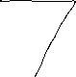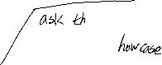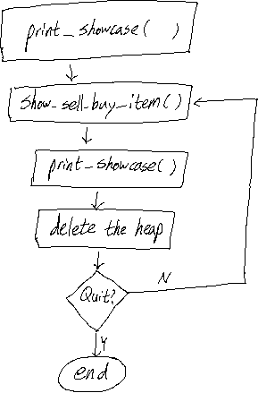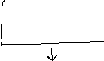

**<create_showcase(int x, int y)>**

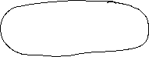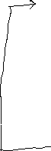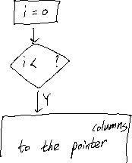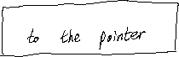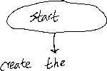

**<print_showcase()>**

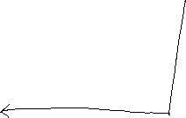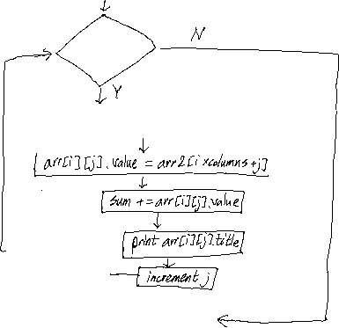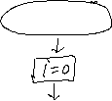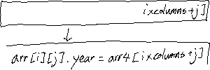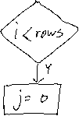

**<show_sell_buy_item()>**

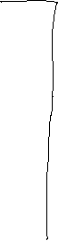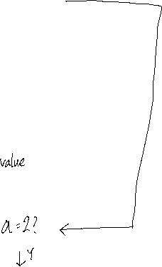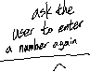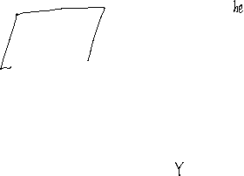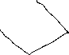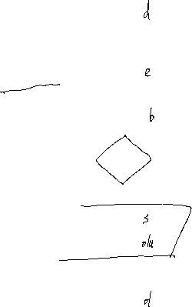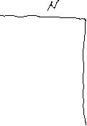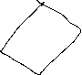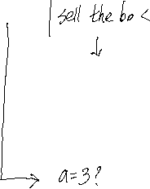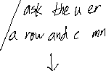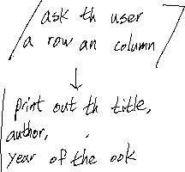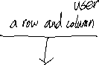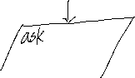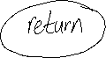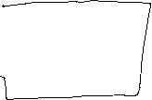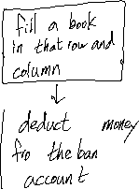

**<Strategy>**

I predict that it will take about three hours to implement this program. First of all, I will set the array of struck to demonstrate the attributes of the books. Secondly, I will make a function that creates a 2D array which size is determined by the user. After the function which creates the 2D array, I will make a function that prints out the 2D array and the total value of item. When making the function that prints out 2D array is completed, I will create a function that shows, sells, and buys a book. In this function, it will prompt the user to do valid choice, and prints out the bank account. For instance, this function will prompt the user to do valid choice when the user is going to buy a book while the showcase is totally full. Finally, I will add a code that asks the user to quit the program or not.

**3.Test Cases**

|  |  |  |
| --- | --- | --- |
| **Setting** | **User input** | **Expected result** |
| Enter a number of rows:  Enter a number of columns: | 1  3 | The Chronicle of the Narnia  The grapes of Wrath  Harry Potter  Total value of 3 items: $870.  Choose 1)show 2)sell 3)buy 4)quit: |
| The Chronicle of the Narnia  The grapes of Wrath  Harry Potter  Total value of 3 items: $870.  Choose 1)show 2)sell 3)buy 4)quit: | 1 | Enter row:  Enter column: |
| Enter row:  Enter column: | 1  3 | Book: title: Harry Potter, author: J.K. Rowling, value: $223, publication year: 1997  Choose 1)show 2)sell 3)buy 4)quit: |
| Book: title: Harry Potter, author: J.K. Rowling, value: $223, publication year: 1997  Choose 1)show 2)sell 3)buy 4)quit: | 3 | Enter row:  Enter column: |
| Enter row:  Enter column: | 1  3 | The showcase is totally full. Please try again: |
| The showcase is totally filled. Please try again: | 2 | Enter row:  Enter column: |
| Enter row:  Enter column: | 1  3 | You sell Harry Potter for $223. Your bank account: $223  Choose 1)show 2)sell 3)buy 4)quit: |
| You sell Harry Potter for $223.Your bank account: $223  Choose 1)show 2)sell 3)buy 4)quit: | 4 | The program is ended. |